New Area 17 Email Server Instructions
In order to cut down on the amount of SPAM being received in our @area17aa.org email accounts and provide better service and user tools we have moved our email system to Google’s Gmail Non-Profit business systems at no cost to us.
We have moved all the email in your current account to the new system so that the change will be as seamless as possible.

Login
In order to login to your email account at Gmail you may still use the login through the A17 Tools sidebar item on our website
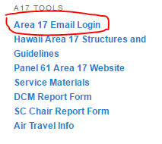
Or simply go to http://gmail.com.
Use your usual Area 17 email address, <your_address>@area17aa.org as your user name. You may encounter a choice between Organizational Google Apps Account and Individual Google Account. You will want to choose the Organizational Google Apps Account:
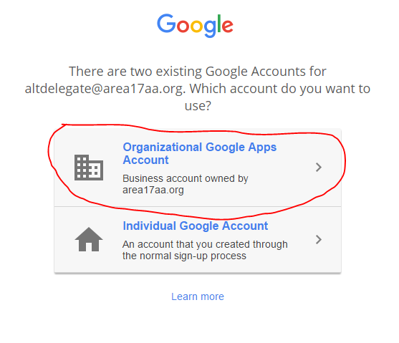
Use the reset password and you should have no trouble logging in. The reset password will be given to you at the May Committee Meeting, or you can email the Webmaster for it. Gmail has extensive help files available.
For those of you who wish to use Outlook, your phone, or another email client, the settings you will want use are found at the following URL:

https://support.google.com/mail/troubleshooter/1668960?hl=en

