

A.A. Grapevine, Inc.

Overview: The board aimed to increase app information, fellowship participation, and subscriptions through strategic planning and app attraction initiatives. GV and LV Editorial teams are busy with new products and upcoming magazine issues. Did you know we have a new online catalog? Websites, podcast, and social media channels are all contributing to an increased online presence. Strategic cost-cutting measures are included in our 2024 budget proposal. The emphasis on product diversification and subscription upgrades fuels revenue growth. La Viña remains a focus for financial improvement strategies and important part of the strategic plan implementation. A new controller has been hired; an official announcement to the fellowship will be made on February 5, 2024. Finally, preparations for the Grapevine's 80th anniversary are underway. Stay tuned for more information!

AA Grapevine, Inc. Financial Report
This budget significantly lowers the shortfall for Grapevine (nearly $300k improvement vs. 2023 July Forecast) and La Viña (nearly $200k improvement). It also provides for the resources to expand the sales of our magazine subscriptions, app subscriptions, books, audio books and other products.

Highlights of this year’s budget include the following:
Cut back on travel: We limit the reimbursement of travel costs to AA events to one staff member and one director. Directors can go to any event they choose, of course, but only the director assigned to the event will be reimbursed by Grapevine. In addition, all Planning Meetings for 2024 will be virtual at a savings of roughly $50k.

Subscription price increase: in 2023 the standard one-year price for a Grapevine subscription was $28.97, La Viña $14.45. As of January 1, 2024 we increased the Grapevine price to $36.00 and are currently weighing a price increase on La Vina as well.

Efforts to increase subscriptions to “GV Complete.” An announcement going out this week to print-only subscribers to upgrade from print to GV complete for just $10. More of these efforts planned for this year. Complete subs have a much higher margin than print only subs.

Expanded book publishing program. Three new products this year, Prayer and Meditation audio book in February, Our Twelve Steps in April, Emotional Sobriety audio book in September. Increased promotion of backlist titles as well.

Hold steady on staff size. Current staff to take on Janet’s duties upon retirement, additional Digital Engagement Editor starts second half of year.

Reductions in freelance help. Actual 2023 costs were reviewed charge by charge. More of work able to be done by staff. New podcast to be shelved for this year.

Adjusted staff costs for La Viña. Reduced staff salary allocations to La Viña because Editor and Assistant Editor have settled in and taken charge. We continue working on long-term plans to get La Viña loss to pre-pandemic levels by increasing print and complete subscriptions and lowering costs.

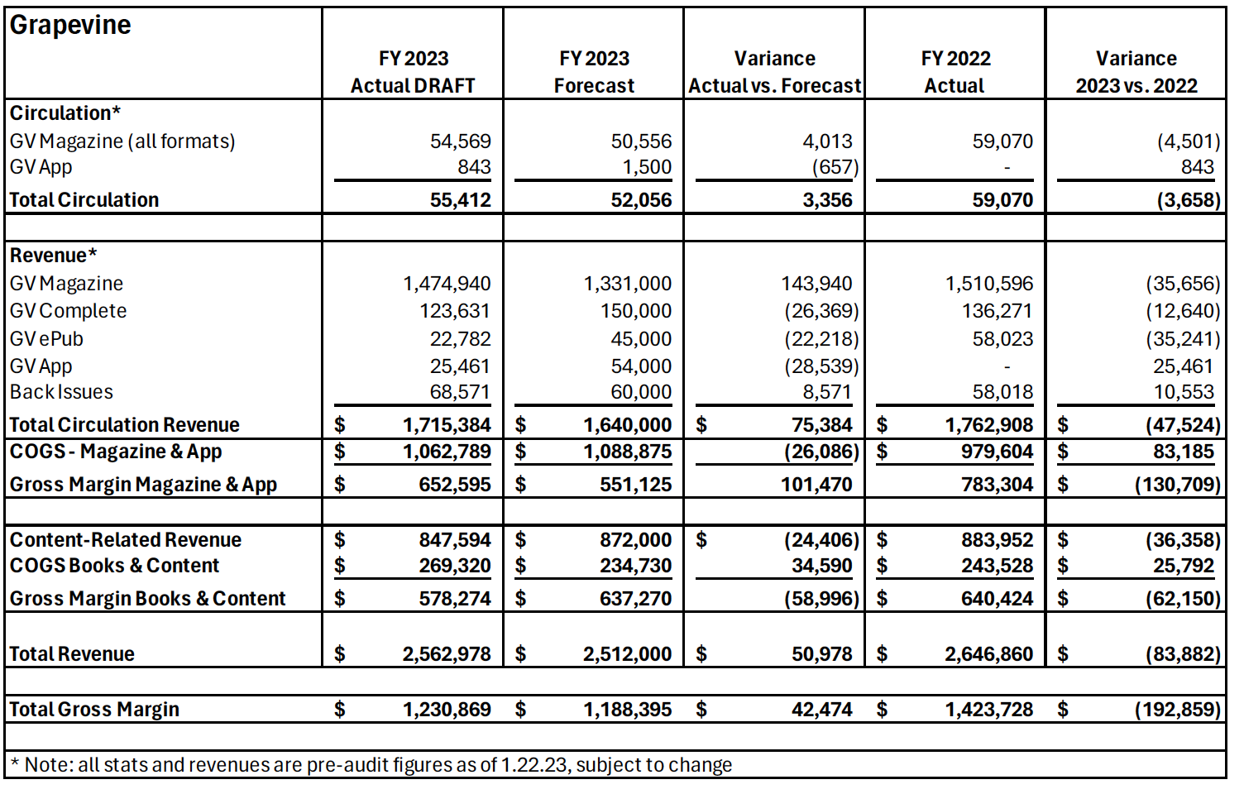

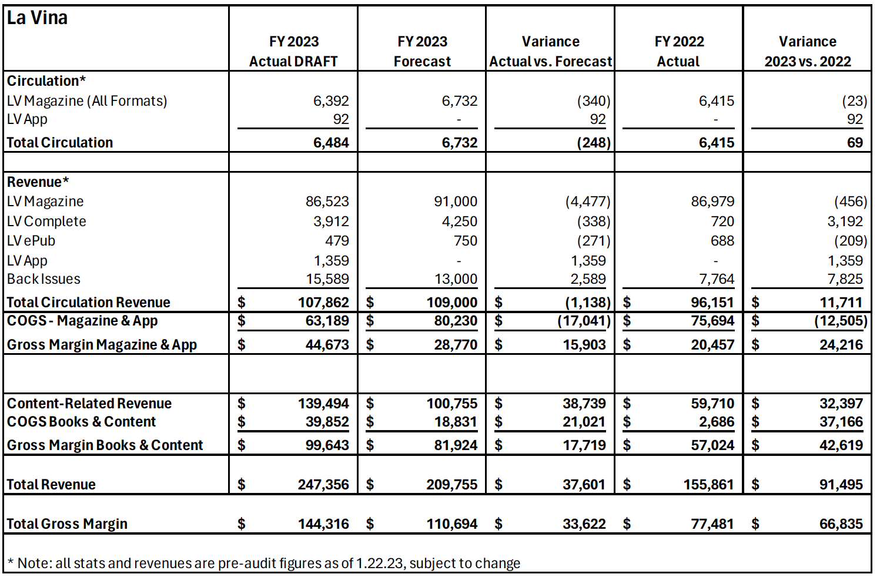

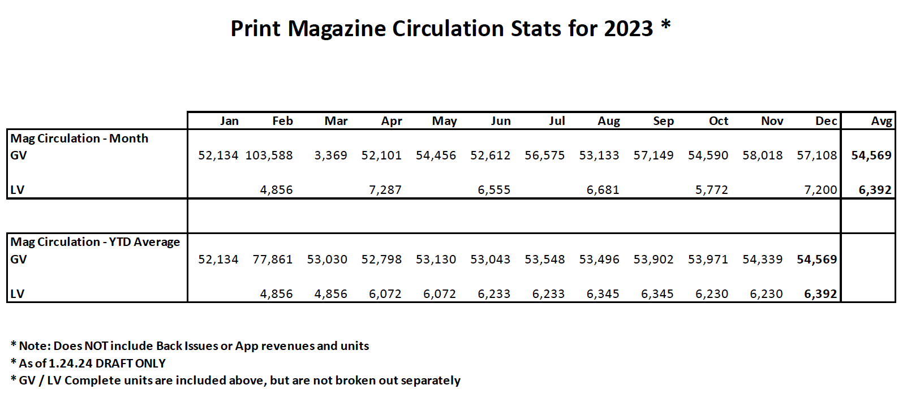

Ad hoc Personnel Handbook: A revised draft from Human Resources will be reviewed by the Dir. of Operations and Publisher and returned to HR if edits are required. Once that process is completed, the draft will be turned over to the committee for their review and recommendation to the full board.

Ad hoc 2025 Convention: The committee discussed GV. LV location possibilities at the Convention, souvenir item as well as other “asks” to be present to the Convention desk.

Management report: The Publisher reported the following:
GV LV App
- Downloads GV = 26,623; New in-app subscriptions = 5,305 (iOS 4,745, Android 560)
- Downloads LV = 1,061; New in-app subscriptions = 143 (iOS 117, Android 26)
- Past month GV iOS use: 20,505 sessions on 3,072 devices
- App user ratings: Google Play 4.8/5; Apple 4.1/5
- Current position on Apple top 200 Magazine and Newspaper apps: 34 — just behind Boston Globe but ahead of Bon Appetit, The San Francisco Chronical and Vanity Fair
- Total app sales to top $100,000 by end of January. GV Inc. revenue to date $66,455
- App attraction efforts: A 13-point plan coming out of our last strategic planning meeting issued to staff and board. Teams developing action plans.
- January special offer out to “print only” subscribers to upgrade to “complete” for only $10.
- Upcoming new products: Prayer and Meditation audio book, February 15; Our Twelve Steps, April 2.
- Podcast: Over 726,000 downloads, continues to grow with this month’s listenership up 11% over previous month; Instagram: Grapevine 11,500 followers, La Viña 1,565 followers; YouTube: 12,400 subscribers, 239 videos with 181,874 views. The podcast is now available on YouTube. Grapevine Channel subscribers and any YouTube user who watches AA related content will get exposure to the podcast on their feeds.
- New YouTube playlist “Blessed” released in January with RSS feed for Podcast.
- Grapevine and La Viña News appearing monthly on the Meeting Guide App.
- App stories to be in Grapevine and La Viña magazines, Grapevine and La Viña News and on the podcast.
- A Grapevine Area Chair Workshop was held on January 18 to inform Area servants about the new apps and answer questions.
- Digital Engagement Editor broadening outreach to GVR/RLV network.
- Director of Operations revising the Business Continuation Plan.
- Customer Relations Coordinator and new fulfillment house Customer Service relationship has been productive.
- Online store updates ongoing.
- New online only 2024 catalogue released (postcard with QR code available).
- Carry the Message certificates processed in 2023: 1,633.

Grapevine Editorial: The senior editor reported the following:
- Recent Grapevine magazines released:
NOV—Gratitude (featuring an interview with Michelle in Archives)
DEC—Remote Communities & Holiday Stories (interview with Mike L.)
JAN—Emotional Sobriety (Regional Forums announcement) - out now
- Grapevine magazines currently in production and on schedule:
FEB—Getting Through Tough Times—done, printing.
MARCH—Spanish Speaking AA Members’ La Viña stories (interview with Paz P.)
APRIL—Favorite Big Book Stories (Big Book 85th Anniv!)—proofing
MAY—How the Steps Changed My Life (Release of brand-new Step Book!)—stories edited, art meeting soon.
JUNE—Happy 80th Grapevine! - Special Issue—editing stories
JULY—Annual Prison Issue—selecting stories.
- Our Twelve Steps—New Spring Book—a brand-new collection of stories from AA members about the joys and challenges of working the program’s Twelve Steps of recovery—on schedule—due out April 2024.
- Working with new Digital Engagement Editor to create content for the new app.
- Early work on special June 2024 GV issue—Grapevine’s 80th Anniversary!!!
- Podcast – working with hosts to connect with interview subjects from current stories in magazine and important GV & LV information.
- Publishing more AA News and interviews with Class A & B Trustees and important AA announcements (working closely with GSO staff desks).
- Early work being done on Emotional Sobriety audiobook (possible Fall 2024)
- Early work is being done on 2025 International Convention product.

La Viña Editorial Report: The La Viña editor reported the following:
- Recent La Viña magazine released:
  - NOV/DEC Alegría (The joy of living)
  - JAN/FEB 2024: Nuevos (Newcomers edition)
- La Viña magazines currently in production and on schedule:
  - MARCH/APRIL: Short stories —Proof 2.
  - MAY/JUNE: Relapse — Copy editing.
  - JULY/AUGUST: Prisons— Selecting stories.
- Stories — 150 new batch of stories received in December only.
- 2025 Editorial Calendar ready and in the website.
- LV informational workshop — last Thursday of the month at 3 pm. We share updates and give presentations of our products. Increasing engagement with Trusted Servants and spreading the word about the App.
- Daily quote: SMS service cancelled. Members can find it in the La Viña App.
- La Viña App: The LV editorial team has developed written and audiovisual materials, in Spanish, focused on the needs expressed in the Hispanic community. Video tutorials to download and use for La Viña application, as well as PowerPoint presentations with the tools and resources that are available to all AA members.
- Working with Digital Engagement Editor, updating and creating content for the app.
Web Report: The Digital Publishing manager reported monthly web traffic in the 4th quarter for GV averaged 292,916 new visitors; 41,000 returning visitors and 598,610 page views. Due to an upgrade to Google Analytics 4, the numbers for LV were not correct and therefore not included in 4th quarter reporting.

