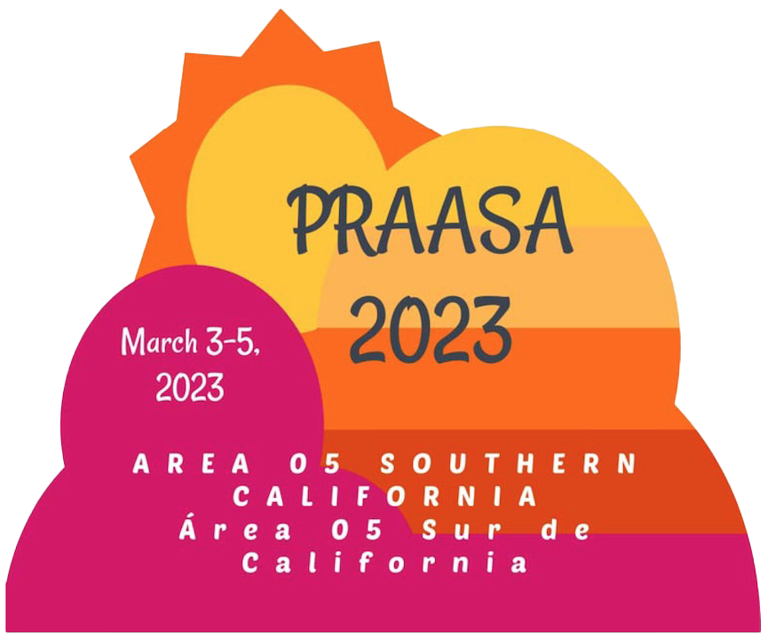

**PRAASA'S PURPOSE**

The purpose of PRAASA is to develop greater unity among the members, groups, and Areas of the Pacific Region; to encourage the exchange of ideas and experiences; and to provide an opportunity for members to discuss pertinent aspects of AA. The Assembly and the PRAASA committee should always foster the Recovery, Unity and Service legacies of AA.

**What Happens at PRAASA**

The Pacific Region Alcoholics Anonymous Service Assembly is a mix of panel presentations, roundtable discussions, open mic sharing, and speakers. Many attendees also come for the great fellowship and bonding that takes place with others from the same service Area and with new friends made from other Areas. Topics for the presentations and sharing are focused on general service. PRAASA is held prior to the General Service Conference and includes topics that will be discussed at the upcoming conference along with issues that are of interest to members involved in general service. Roundtables provide an opportunity for members to discuss topics with people who have the same service position, like the Corrections and DCM roundtables, or who are interested in a particular topic, like YPAA or technology. Come join over 1000 excited AA members from all over the Pacific Region and be part of this unforgettable event!

**Who Attends PRAASA**

Anyone can attend! Those who are involved in general service at the district or Area levels are generally the most interested in the topics that are discussed at PRAASA, but it's also a great way to get inspired into doing general service, so all A.A. members are welcome and encouraged to attend.

**Where is PRAASA Held**

PRAASA is an annual conference hosted by one of the 15 areas in the Pacific Region of Alcoholics Anonymous on a rotating basis. This means that each area has the opportunity to host PRAASA roughly every 15 years. This year, the conference is being held in Los Angeles, California and hosted by Southern California Area 05.