WEST HAWAII, DISTRICT 8
ALOHA MANA ANNUAL
ROUNDUP

CELEBRATE RECOVERY
SEPTEMBER 26, 27, 28, 2008
September 26, 27, 28, 2008
Spencer Beach Park

September 26, 27, 28, 2008
Spencer Beach Park

SPENCER BEACH STATE PARK,
BIG ISLAND HAWAII

COME AND ENJOY
CAMPING, MEETINGS, FELLOWSHIP,
and ONO GRINDS
Celebrate Recovery

Please Register Early:
The Roundup is self-supportin. Money collected early is used for Roundup costs. It helps secure the entire camp-site, any portable toilets required, supplies and other costs.

Accommodations:
This is a camp out. There will be no housing provided. Bring your camping gear; cooking utensils, flashlights, sleeping gear etc. There will be a meal provided Saturday night, no other meals will be provided. Barbeques, showers and toilets are available on-site.

If you do not want to camp there are some Bed & Breakfasts and hotels on the Kona/Kohala coast. In the spirit of non-affiliation based on proximity are some of the following.

Puako Bed and Breakfast: (808) 882-1331
Hale Ho’onanea Bed and Breakfast: (808) 882-1635
The Hapuna Prince: (808) 882-6060

Registration Deadline - September 7, 2008

Registration Includes:
Meeting, Fellowship, Camping,FRIDAY and SATURDAY Evening Meal, plus SUNDAY BREAKFAST and much, much more.

Cost per person | Number of people | Sub-total
Adults - $50.00
Children under 12 - $15.00
TOTAL

Please do not mail cash.  There will be a $20.00 fee assessed to all returned checks.  Mail To: Roundup  PO Box 2154  Kailua-Kona HI 967845 | Make checks payable to Roundup
Payment enclosed - TOTAL | $

NO REFUNDS - Registrations may be transferred
Name:
Address:
E-mail Address:
Phone:
Additional Names for Registration:

DIRECTIONS TO THE PARK LOCATION
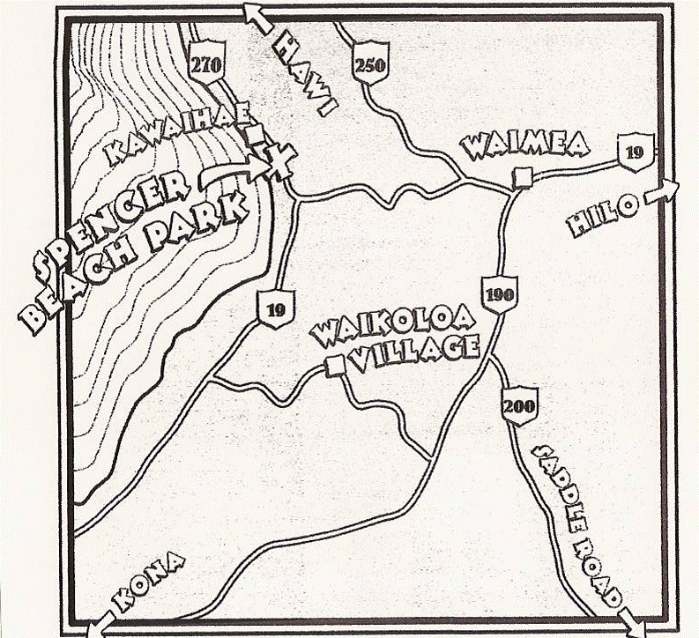
The Roundup is being held at Spencer Beach Park located on the North-West coast of the Big Island from September 26, 27, 28, 2008. With excellent camping facilities.

