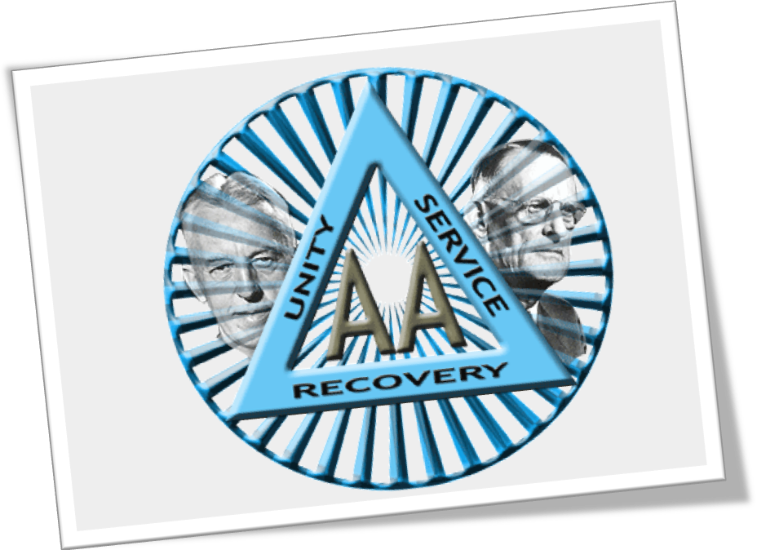
HONOLULU DISTRICT:
*
NEW YEARS ALKATHON

@ UNITY CHURCH…FROM DECEMBER 31, 2008 500PM – JANUARY 1, 2009 500PM

FOOD, FELLOWSHIP, FUN.
YOU DON’T HAVE TO BE ALONE THIS NEW YEARS. COME SPEND THIS JOYOUS HOLIDAY AT THE NEW YEARS ALKATHON AT UNITY CHURCH LOCATED @ 3608 DIAMOND HEAD CIRCLE. THERE WILL BE MEETINGS AROUND THE CLOCK FOR 24 HOURS PLUS. FOOD DONATIONS CALL LISA K. @ 6580504.MEETINGS CALL MEL @ 3548444.

