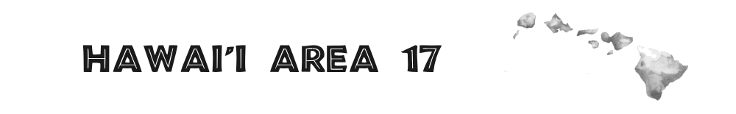 2026 Elections Assembly
Hosted by District 1 - Diamond Head
Saturday, Nov 7, 2026 & Sunday, Nov 8, 2026
Queen Kaahumanu Elementary School
1141 Kinau Street Honolulu, HI 96814

Chair: dcm1@area17.org Phone: (501) 777-8087
Registration Chair: assembly-registration@area17aa.org
Transportation Chair: assembly-transportation@area17aa.org
Homestay Chair: assembly-homestay@area17aa.org

Saturday: Call to Order 9:00 AM – Adjourn 5:00 PM
Sunday: Call to Order 9:00 AM – Adjourn 4:30 PM

Registration & Breakfast 8:00 – 9:00 AM

------------------------------------------------------------------------------------------------------------------------------

REGISTRATION FORM
Complete your form and mail it along with the $35.00 registration fee to:
PO Box 240393, Honolulu, HI 96824
Make your check or money order payable to: Diamond Head District

Full Name: ____________________________________________

Email: ________________________________________________

District/Service Position: ________________________________

Phone Number: ________________________________________

Do you require:
____Transportation ____Homestay _____Vegetarian _____Saturday Dinner
Homestay deadline: October 31, 2026

Placement is NOT guaranteed after the deadline
Flight Info: Airline: ____________________ Date of Arrival:____________________
Arrival Time: ________________ Departure Time: __________________

